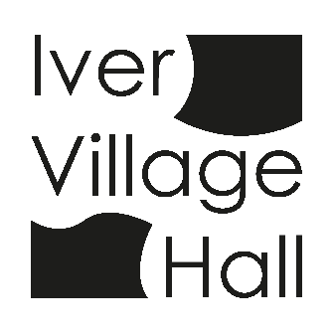
IVER COMMUNITY ASSOCIATION
IVER VILLAGE HALL

EQUAL OPPORTUNITIES POLICY

It is the policy of the Management Committee not to discriminate directly or indirectly against anybody (whether staff, volunteers, committee members, users or the community in general) on the grounds of race, gender, sexual orientation, age, disability, religious or political beliefs or marital status.

Harassment and Discrimination
The Village Hall Trust guarantees to deal quickly and firmly with all forms of harassment or discrimination (i.e. sexual, racial etc.) including physical attacks on persons, damage to property, oral or verbal abuse; whether this is by groups and individuals using the Village Hall, taking part in activities organised on or behalf of the Trust, members of staff, committee members or volunteers.

