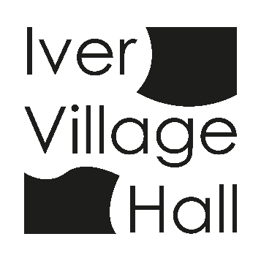

IVER COMMUNITY ASSOCIATION
IVER VILLAGE HALL

Policy for Activities involving Children and Young People

The Management Committee are committed to providing children and young people with appropriate safety and protection whilst in Iver Village Hall.
The management will endeavour to make sure that hirers are aware that they are responsible for ensuring that any activities for children and young people comply with the provisions of all current legislation and that only fit and proper persons have access to the children in their care.
The Management Committee will make clear to hirers that groups working with children and young people must have a current Child Protection Policy.

