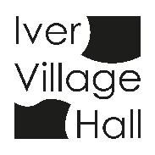
IVER COMMUNITY ASSOCIATION
IVER VILLAGE HALL

Iver Village Hall Safeguarding Policy
- We are committed to:
  - The care of all children and adults using the facilities of Iver Village Hall.
  - The safeguarding and protection of all children, young people and adults when they are vulnerable.
  - The establishing of a safe environment where there is a culture of ‘informed vigilance’ as to the dangers of abuse.

- We will carefully screen all applications for use of the Village Hall to ensure that activities being planned include appropriate safeguarding risk assessments and the use of Criminal Records disclosures by specific organisations and groups as the Management Committee deems necessary.

- We will respond without delay to every complaint made which suggests that an adult, child or young person may have been harmed while using our premises, co-operating with the police and local authority in any investigation and we will have a clear reporting procedure in place.

- We will seek to challenge any abuse of power, especially by anyone in a position of trust.

- In all these principles we will follow statute, guidance and recognised good practice.

- We will review this policy annually, check that our policies are up to date, and display this statement in a place of prominence within our building.

